1.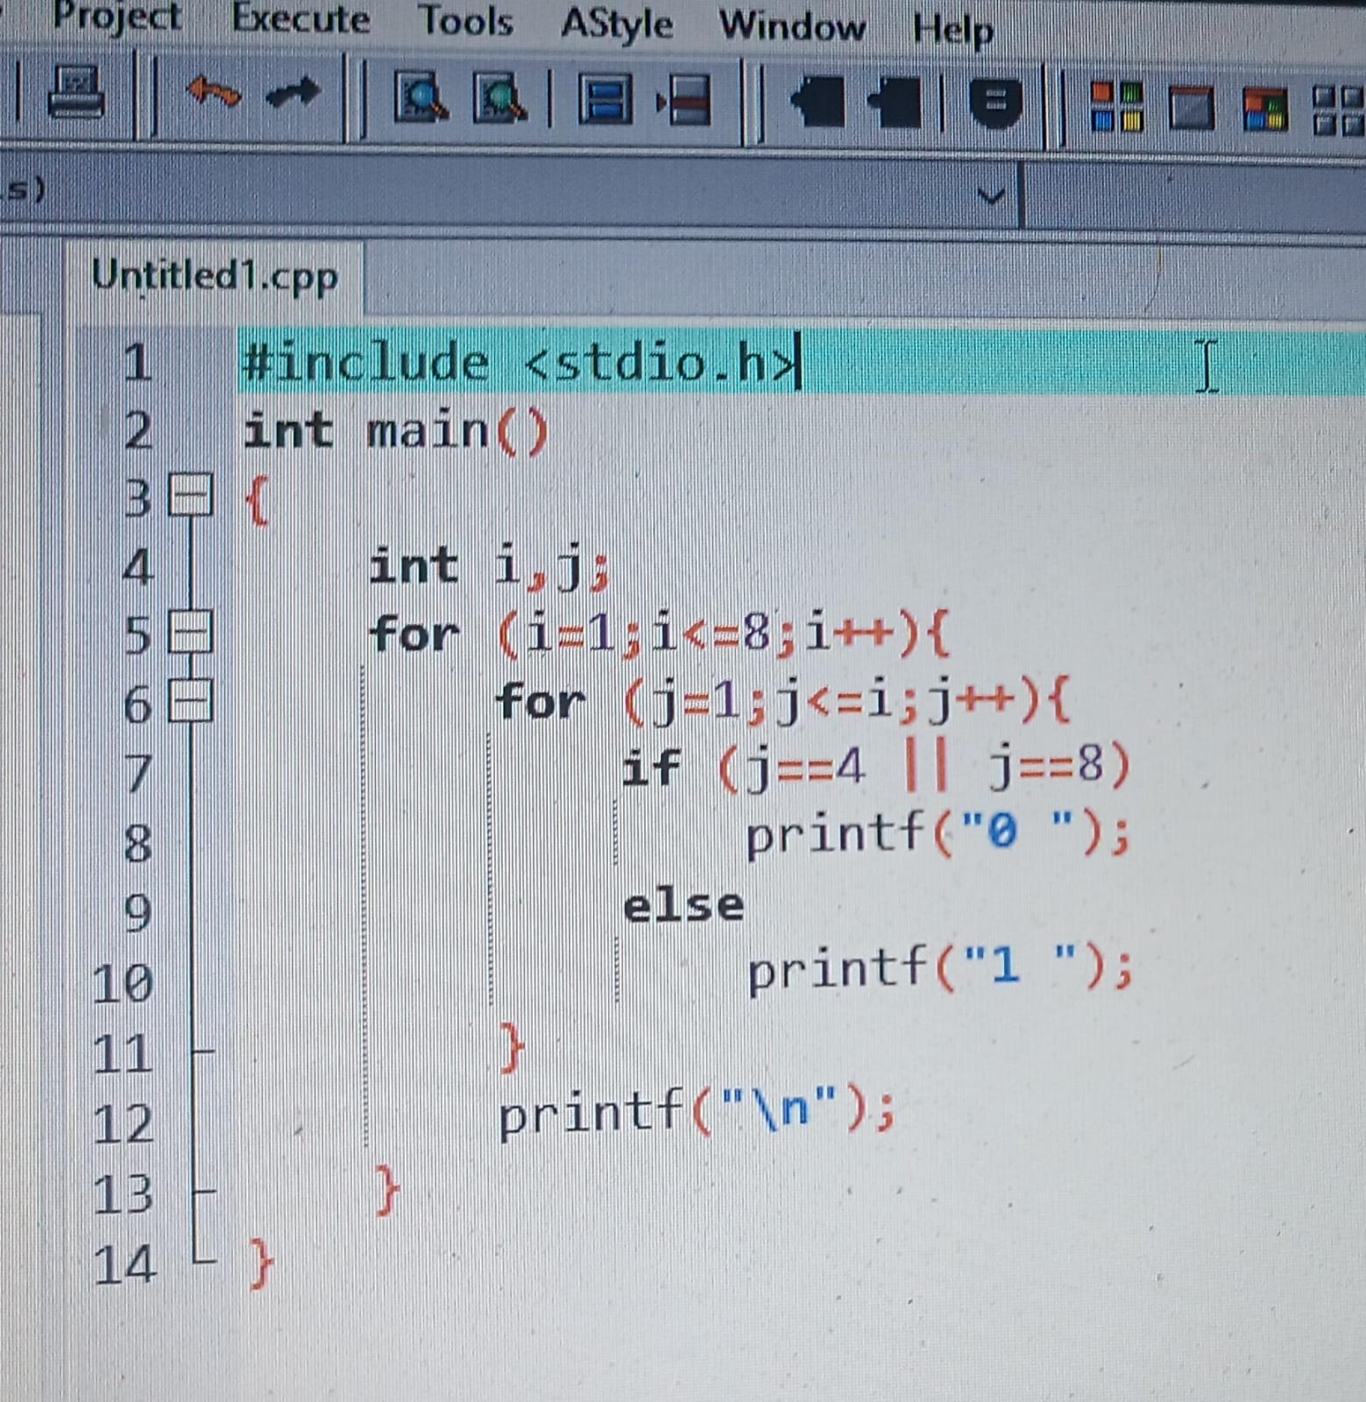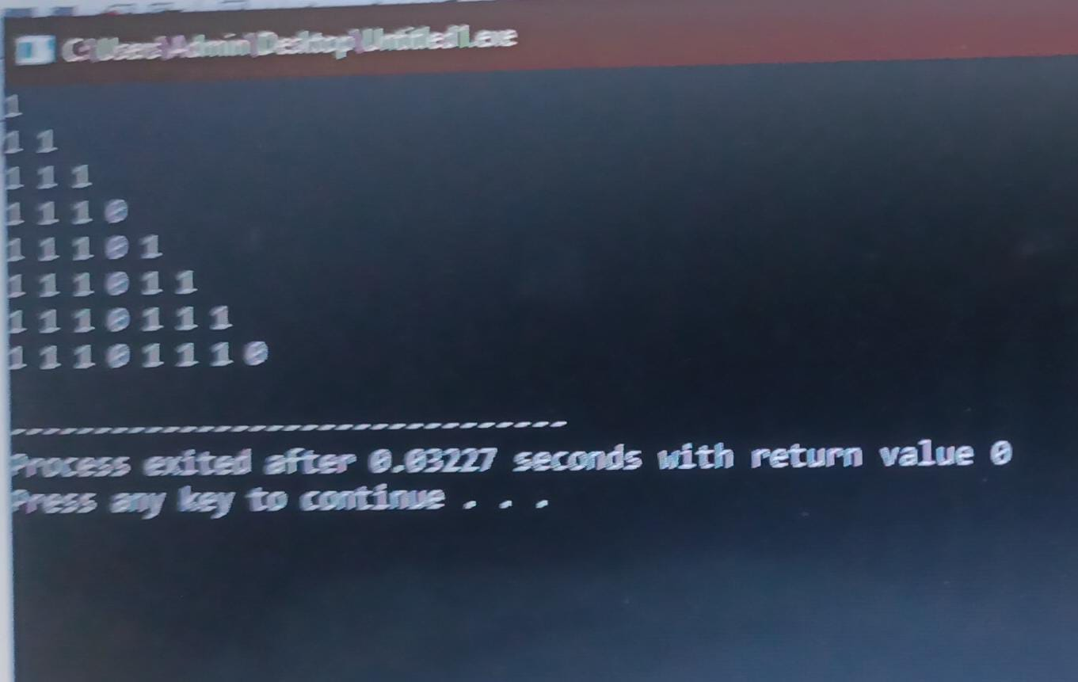
2.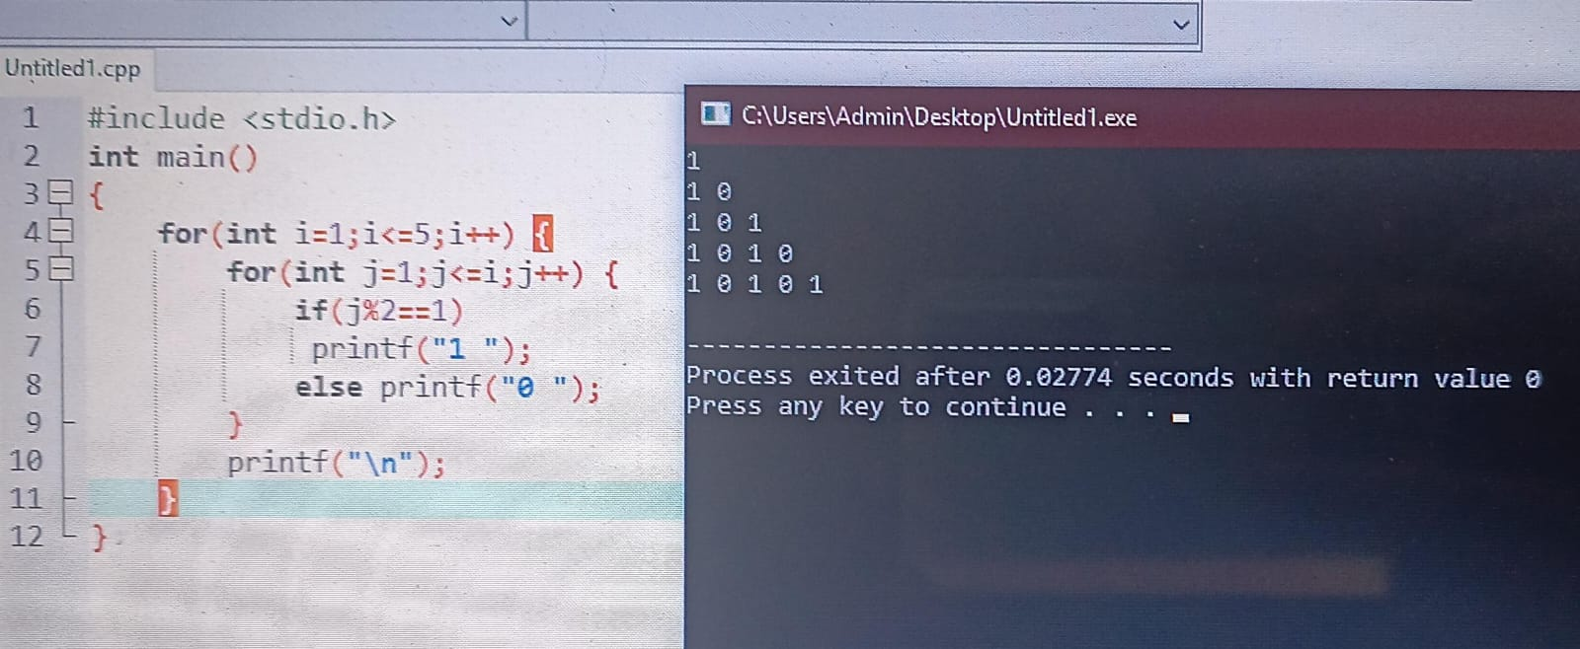
3.
#include <stdio.h>
int main()
{
int a[3][3], b[3][3], sum[3][3];
printf("enter matrix A(3x3):\n");
for(int i=0;i<3;i++) for(int j=0;j<3;j++) scanf("%d",&a[i][j]);

printf("enter matrix B(3x3):\n");
for(int i=0;i<3;i++) for(int j=0;j<3;j++) scanf("%d",&b[i][j]);

for(int i=0;i<3;i++) for(int j=0;j<3;j++) sum[i][j]=a[i][j]+b[i][j];

printf("\nmatrix A:\n");
for(int i=0;i<3;i++){ for(int j=0;j<3;j++) printf("%d ",a[i][j]); printf("\n"); }

printf("\nmatrix B:\n");
for(int i=0;i<3;i++){ for(int j=0;j<3;j++) printf("%d ",b[i][j]); printf("\n"); }

printf("\nsum matrix:\n");
for(int i=0;i<3;i++){ for(int j=0;j<3;j++) printf("%d ",sum[i][j]); printf("\n"); }
}
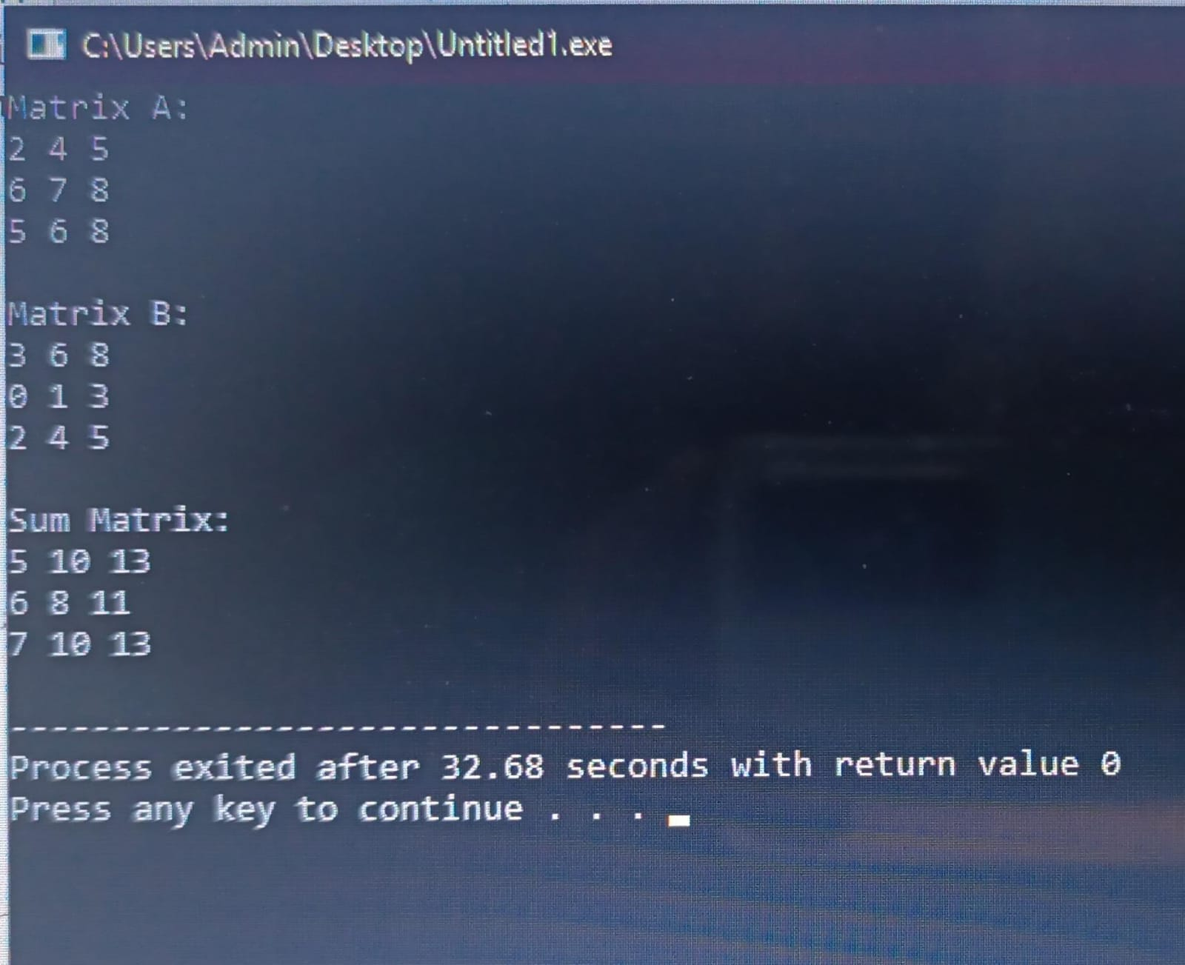
4.
#include <stdio.h>
int main()
{
int marks[4][2];
printf("enter mid and final for 4 students:\n");
for(int i=0;i<4;i++){
printf("student %d: ",i+1);
scanf("%d %d",&marks[i][0],&marks[i][1]);
}
int maxMid=marks[0][0], maxFinal=marks[0][1], minMid=marks[0][0], minFinal=marks[0][1];
int maxOverall=marks[0][0], minOverall=marks[0][0];
float sumMid=0, sumFinal=0;

printf("\n1. total per student:\n");
for(int i=0;i<4;i++){
int total = marks[i][0]+marks[i][1];
printf("student %d total = %d\n",i+1,total);

if(marks[i][0]>maxMid) maxMid=marks[i][0];
if(marks[i][1]>maxFinal) maxFinal=marks[i][1];
if(marks[i][0]<minMid) minMid=marks[i][0];
if(marks[i][1]<minFinal) minFinal=marks[i][1];

for(int j=0;j<2;j++){
if(marks[i][j]>maxOverall) maxOverall=marks[i][j];
if(marks[i][j]<minOverall) minOverall=marks[i][j];
}
sumMid+=marks[i][0];
sumFinal+=marks[i][1];
}
printf("\n2. Highest -> Mid: %d, Final: %d, Overall: %d\n",maxMid,maxFinal,maxOverall);
printf("3. Lowest -> Mid: %d, Final: %d, Overall: %d\n",minMid,minFinal,minOverall);
printf("4. Average -> Mid: %.2f, Final: %.2f\n",sumMid/4, sumFinal/4);
}
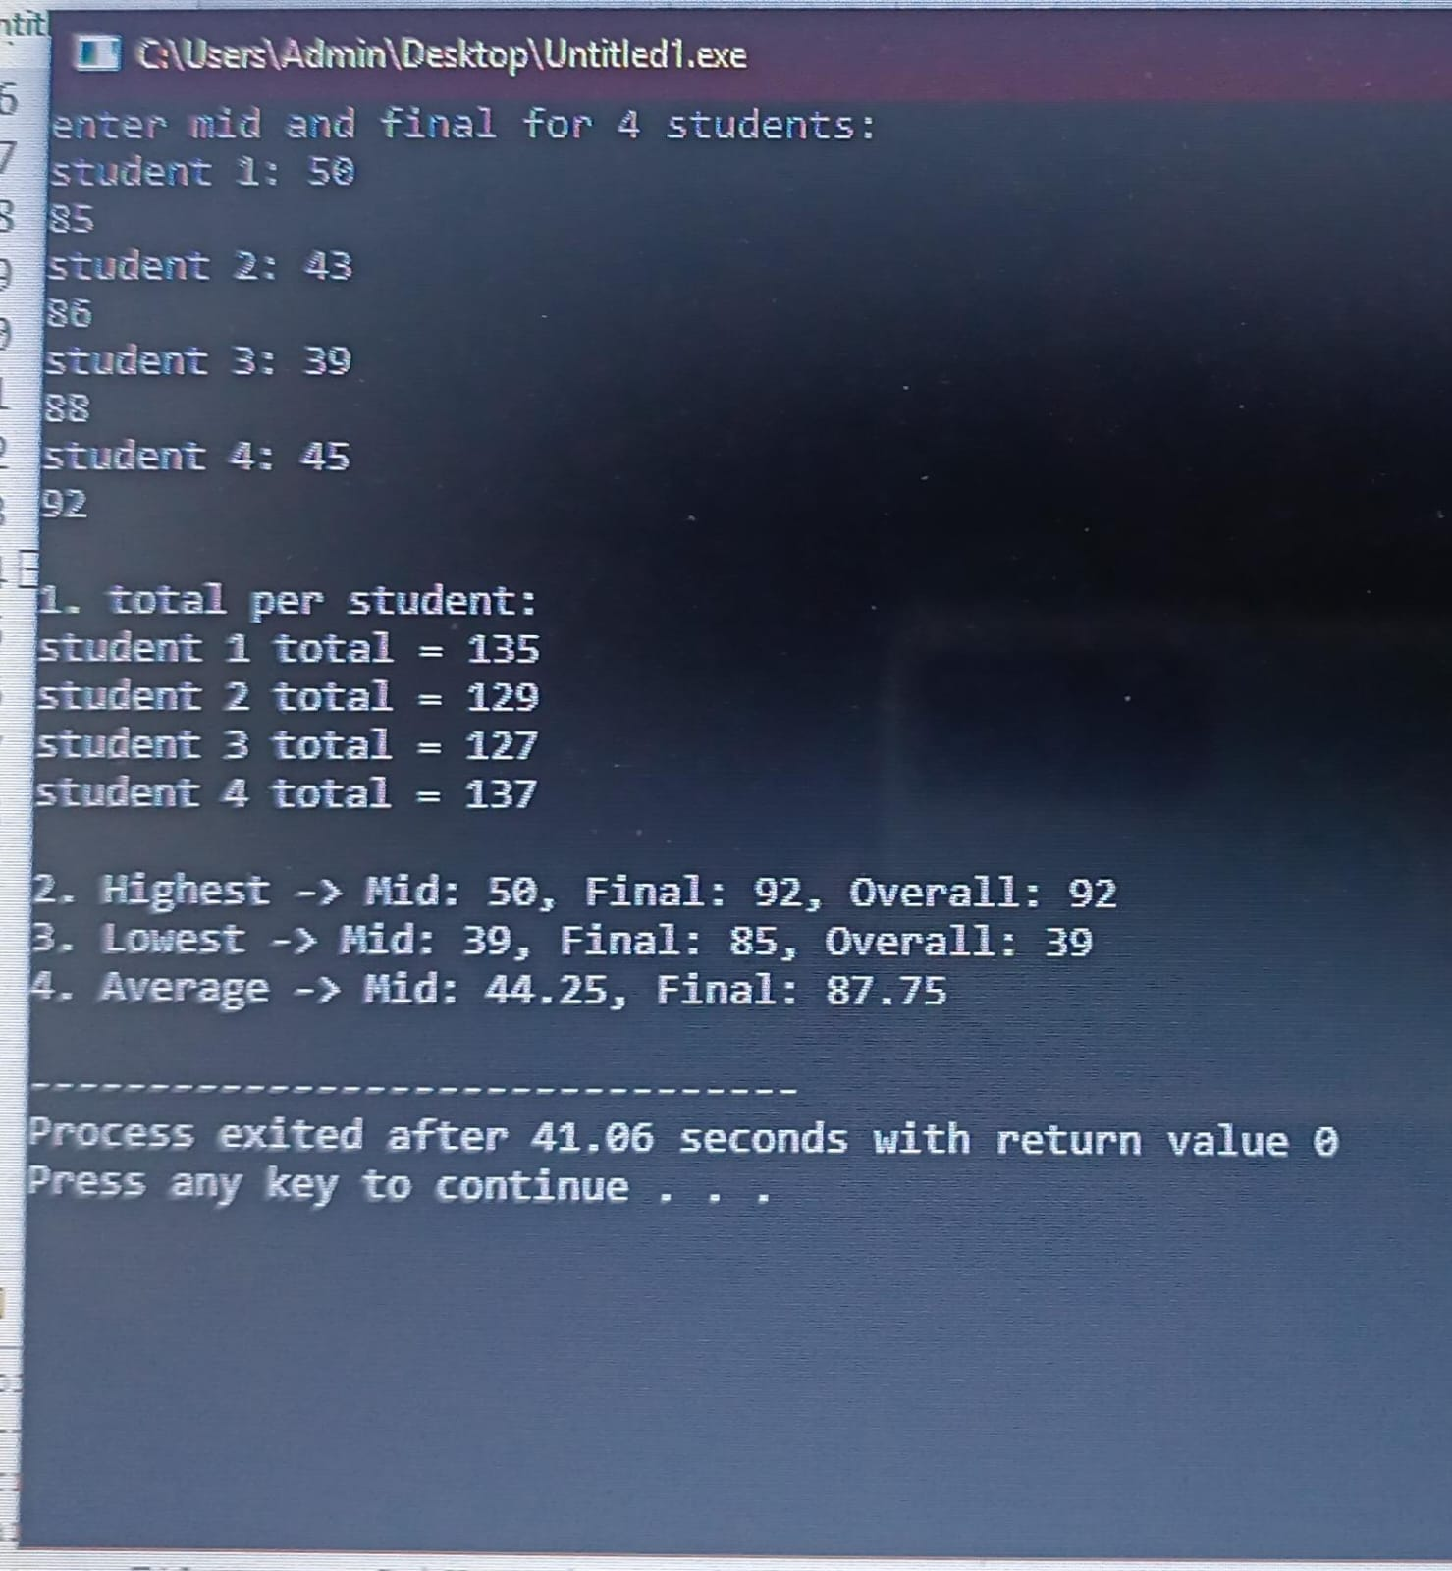

5.
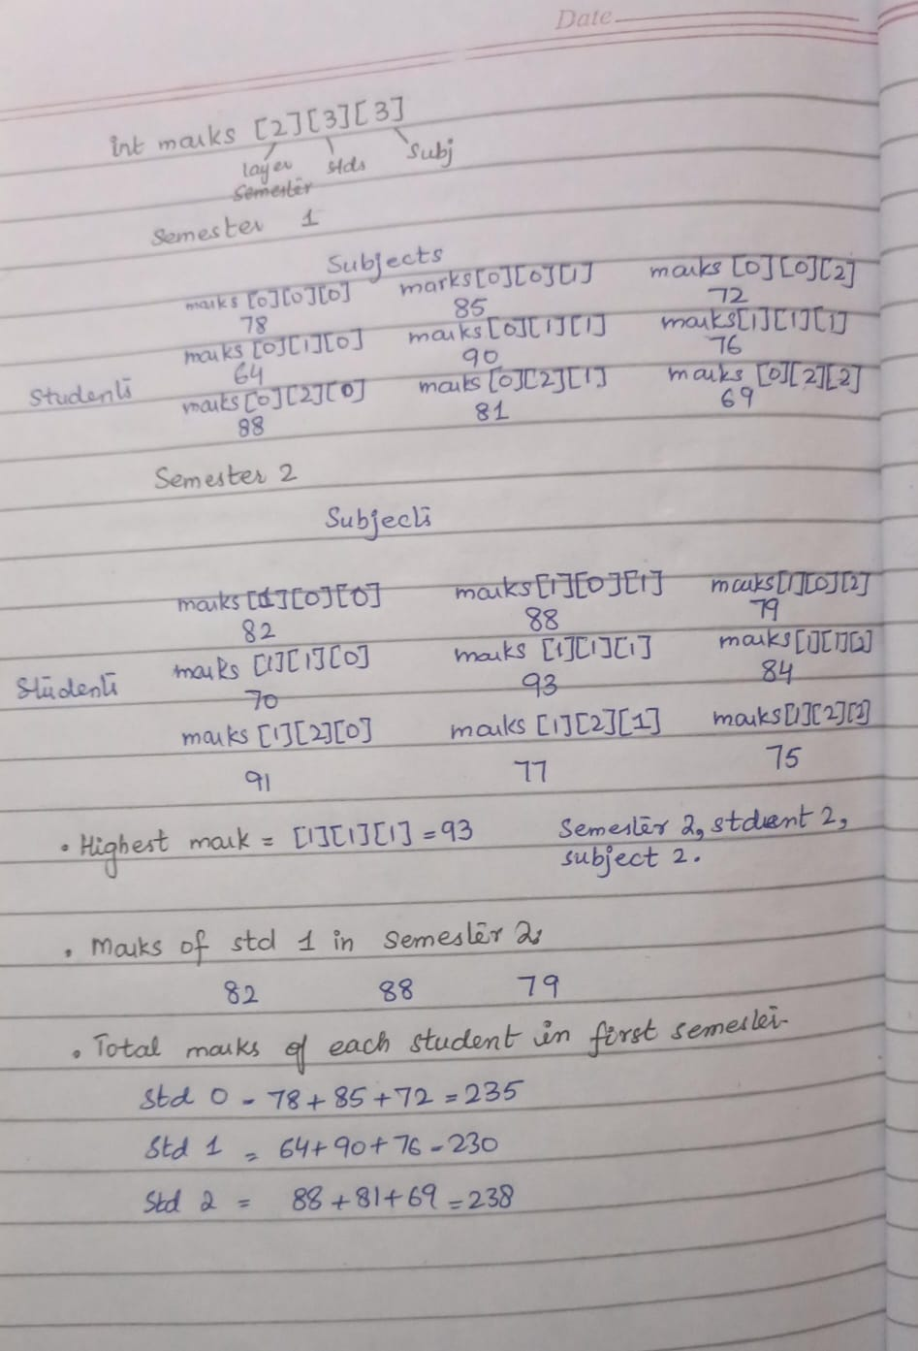
6.
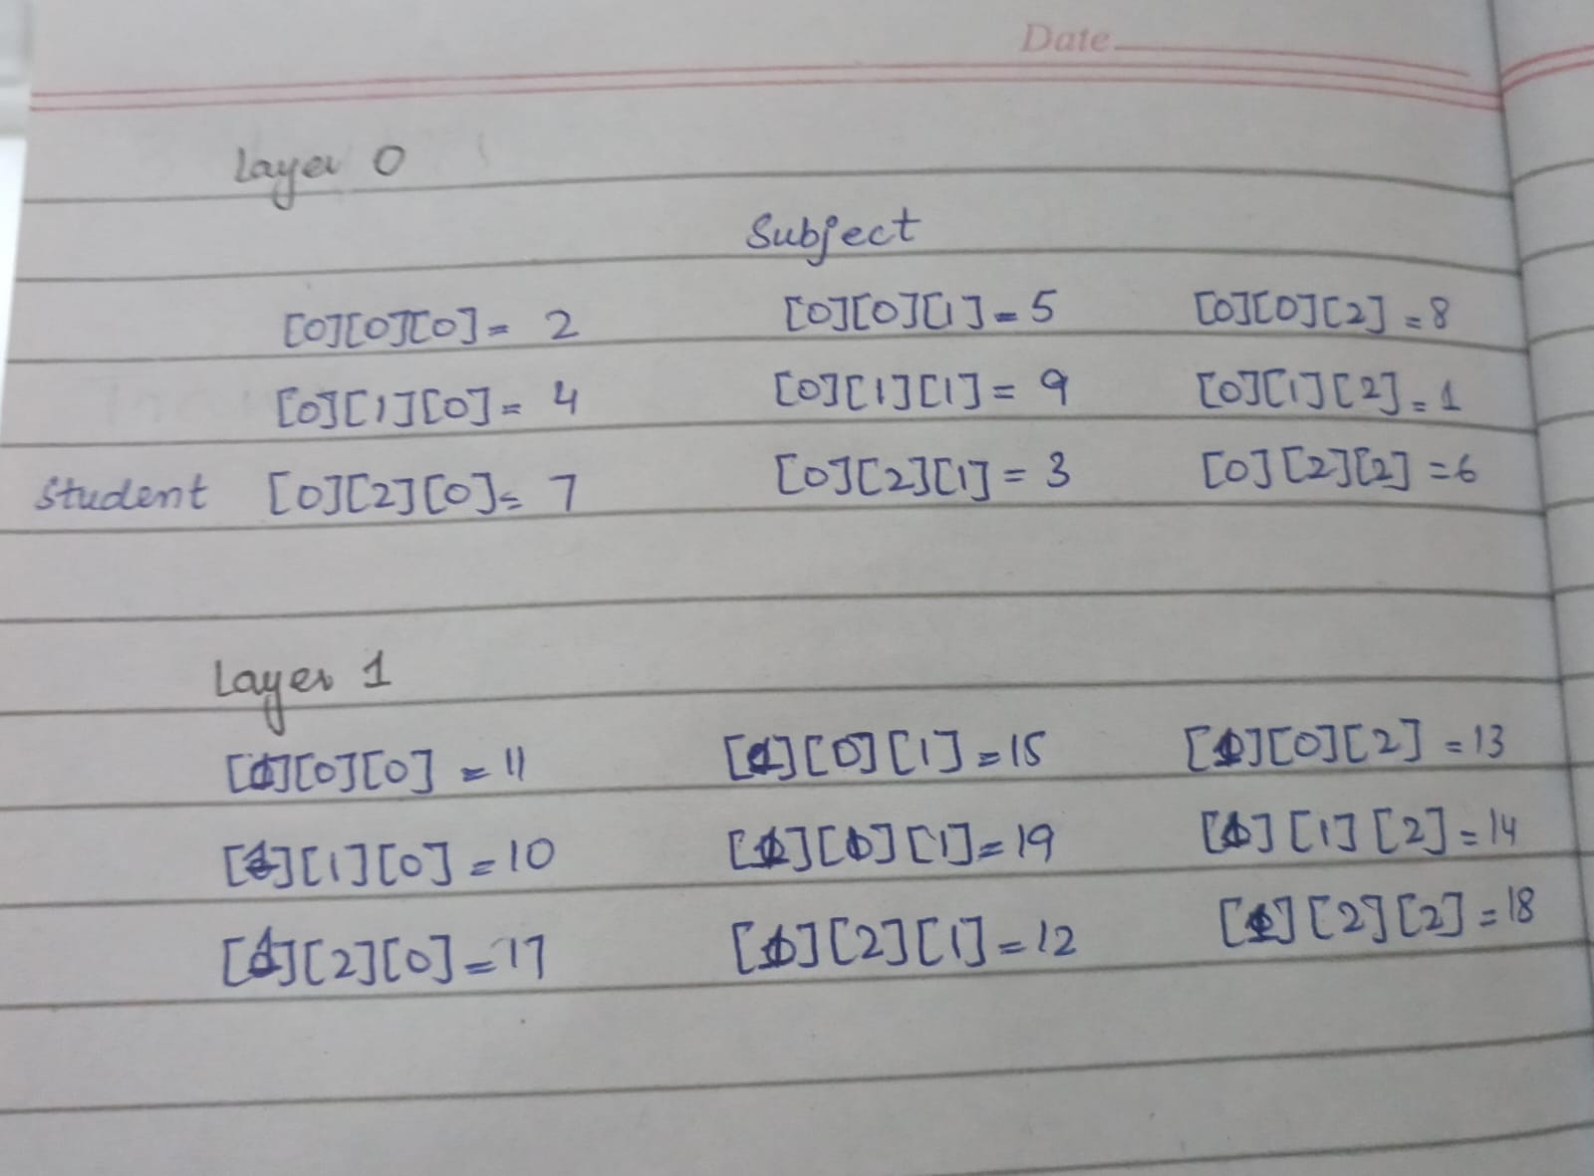
7.
#include <stdio.h>
int main()
{
int salary[3][4][3];
int highest=salary[0][0][0], hd=0, he=0, hm=0;
int deptTotal=0;
int empTotal=0;

printf("enter salary for 3 dept, 4 emp, 3 months:\n");
for(int d=0;d<3;d++) for(int e=0;e<4;e++) for(int m=0;m<3;m++) scanf("%d",&salary[d][e][m]);

for(int d=0; d<3; d++){
printf("\nDepartment %d:\n",d+1);
for(int e=0;e<4;e++){
for(int m=0;m<3;m++){
empTotal+=salary[d][e][m];
deptTotal+=salary[d][e][m];
if(salary[d][e][m]>highest){
highest=salary[d][e][m]; hd=d; he=e; hm=m;
}
}
printf(" employee %d total 3 months = %d\n",e+1,empTotal);
}
printf(" dept %d total = %d, average monthly = %.2f\n",d+1,deptTotal,deptTotal/3.0);
}
printf("\nhighest salary = %d at dept %d, emp %d, month %d\n",highest,hd+1,he+1,hm+1);
}
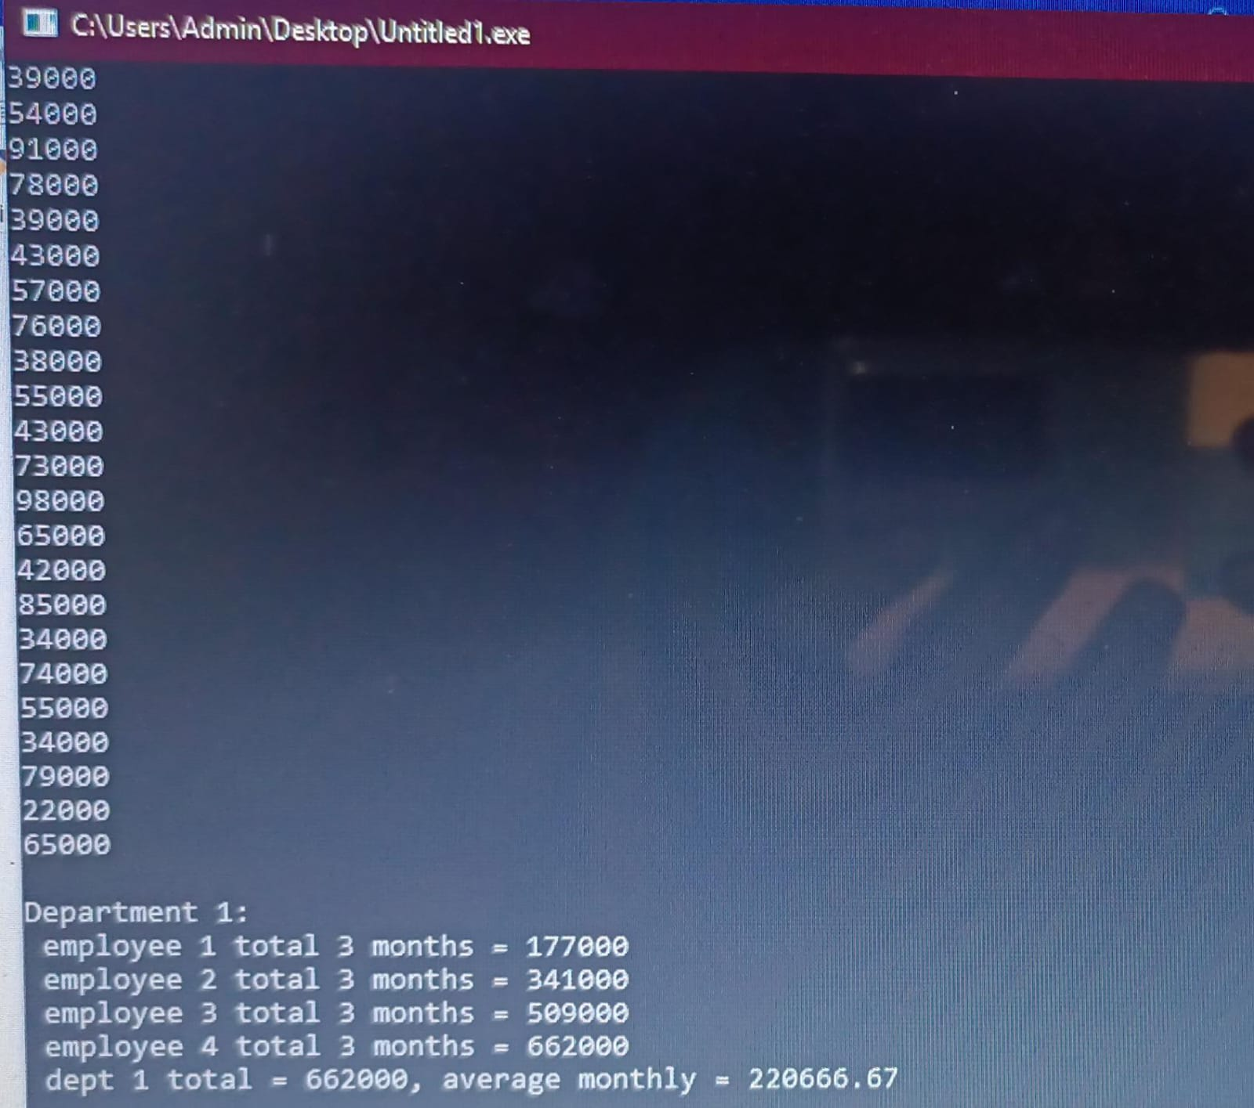
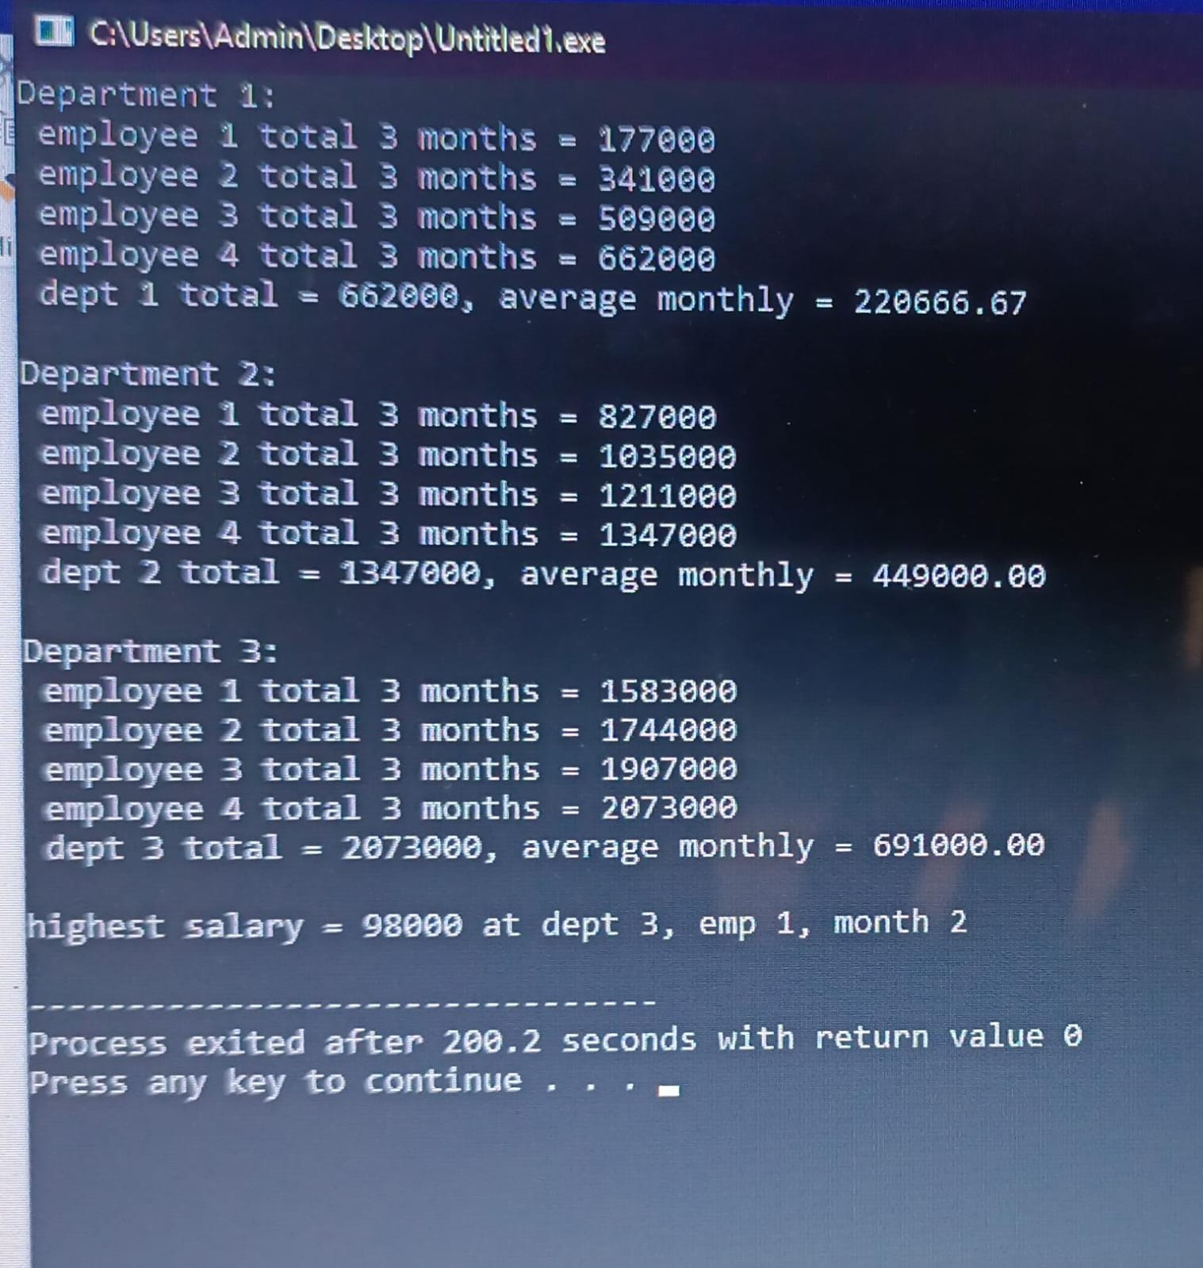
8.
#include <stdio.h>
int main()
{
int marks[2][5][4];
int secTotal=0, maxTotal=-1, topStudent=0;
printf("enter marks (2 sections, 5 students, 4 assignments, out of 10):\n");
for(int s=0;s<2;s++) for(int st=0;st<5;st++) for(int a=0;a<4;a++) scanf("%d",&marks[s][st][a]);

for(int sec=0; sec<2; sec++){
printf("\n section %d\n",sec+1);
for(int st=0; st<5; st++){
int total=0;
for(int a=0;a<4;a++) total+=marks[sec][st][a];
secTotal+=total;
printf(" student %d total = %d",st+1,total);
if(total<20) printf(" -> below 20! need improvement");
printf("\n");
if(total>maxTotal){ maxTotal=total; topStudent=st; }
}
printf(" section %d total = %d\n",sec+1,secTotal);
printf(" top Student = Student %d (Total %d)\n",topStudent+1,maxTotal);

printf(" average per assignment:\n");
for(int a=0;a<4;a++){
float sum=0;
for(int st=0;st<5;st++) sum+=marks[sec][st][a];
printf(" assignment %d avg = %.2f\n",a+1,sum/5);
}
}
}
